**Checklist for Writing**

1. I have run the **spelling checker** on my document.
2. I have run the **grammar checker** on my document.
3. I have used **passive voice** only to avoid first person, and have avoided other wordy constructions such as “there are … who.”
4. I have used the **equation editor** (*download MS Word file*) to format all equations.
5. All of the references in the **List of References** are explicitly cited in my report
6. All of the **figures and tables** have references to them in the text.
7. All **figure captions** appear at the *bottom* of the figure, and all **table captions** appear at the *top* of the figure.
8. The first **reference to each figure** or table must occur *before* the figure or table.
9. The words **“this,” “that,” “these,” and “those”** never occur without referencing a noun. (E.g., “This device is used to …” rather than “This is used to …”
10. All **acronyms or initialisms** are spelled out completely the first time they are used. For example, “A Magnetic Resonance Imager (MRI) is used for ….”
11. All **quoted material** relates to points that are subjective or a matter of opinion on the part of the quoted author.
12. I have not used any of the following **egregious words or phrases**: a lot, kids, kinds, big, kind of, due to the fact that, (or just “the fact that”), utilize, actually, obviously, rather (as in “It is rather surprising”), very, quite, essentially. That is, I have used the search feature of Word to look for the words and phrases in Tables 1 and 2.
13. My text has no **sentence fragment**s or **run-on sentences** (the grammar checker should find these errors).
14. My text has no **contractions** (do a global search for the apostrophe and make sure it occurs only in possessives).
15. The phrase **“*et al.*”** is correctly written, with no period after “et” and a period after “al.”
16. When the **semicolon** is used, it separates complete sentences, not sentence fragments or clauses.
17. I have eliminated **dangling participles**. Wherever a present participle is used at the beginning of a sentence, the noun performing the action is the first thing after the comma.
18. I have used **parallel constructions** in related phrases.
19. I have checked for **common typing errors**.

**Checklist for Graphs**

1. Where possible and appropriate, multiple related curves are plotted on the same graph so that they can be readily compared. (How?)
2. The graph background is white. (How?)
3. The “Smoothed line” option is turned *off*. If no theoretical curve or appropriate curve fit, I have not connected the symbols or have connected them with ***straight*** lines (How?).
4. Collected data are represented with symbols, and theoretical curves or digitized waveforms with lines (How?).
5. Line modes, line thicknesses or symbols distinguish data sets, ***not*** colors (How?).
6. The horizontal gridlines are removed from my plots (How?).
7. Major tick marks are included on the axes to indicate the positions corresponding to the number labels (How?).
8. The numbers on the x and y axes are large enough to read (How?).
9. The scales on the x and y axes follow the 1, 2, 5 rule (How?).
10. The x and y axes are labeled clearly with the information they represent and the correct units of the data (e.g. Frequency (Hz) or Pressure (dynes/cm2)) (How?).
11. The y-axis labels (title and numbers) run vertically from the bottom of the plot to the top, rather than horizontally (How?).
12. Greek letters, other special characters, or superscripts/subscripts are used, when necessary, in an axis title or elsewhere (How?).
13. The legend for each curve describes only the distinguishing characteristic of the curve (e.g. “With Fibrinogen”, “Without Fibrinogen,” ***not*** “Cell Growth With Fibrinogen,” “Cell Growth Without Fibrinogen,” ***not*** “first data set,” “second data set,” and ***certainly not*** “series 1,” “series 2.”) (How?).
14. No chart title is used unless multiple graphs appear in a single figure. (How?)
15. The legend is on the plot area at a location where it does not cover any of the data. (How?)
16. Where applicable, the legends appear in an order that follows the position of the curve on the plot (i.e., upper curve matches the topmost legend) (How?).
17. Legends highlight only the aspect of the given curve that distinguish it from the other curves. (Generally, if all legends have a phrase in common, that phrasecan be removed).
18. Unnecessary borders are removed, including:
    * + - 1. The border around the legend.
          2. The border around the plotting area.
          3. The border around the complete plot. (How?)
19. Where applicable, bars representing standard deviation or standard error of my collected data are included (How?).
20. Where reasonable, physical units for the axes allow the number labels to have a small number of digits (e.g. 10 GPa instead of 10E9 Pa or 10,000 MPa) (What?).

**Checklist for Figures and Tables Figures**

Each figure caption appears below the figure.

A consistent caption style is used for all figures.

Each figure is referenced within the narrative of the document.

A description of the figure follows the reference to that figure, usually before the picture appears.[1]

Each figure appears after the narrative paragraph that first introduces it.

Figures do not break across pages.

**Tables**

Each table caption appears above the table. (It’s a general rule. Don’t ask me why.)

Each table is referenced, by table number, within the narrative of the document.

Each table appears after the first reference to it within the narrative.

Each caption includes the word “Table,” followed by the table number.

A consistent style is used for all tables.

Tables that are less than one page long do not break across pages.

Tables that are longer than one page long include a separate table header for each page.

**Laboratory Member Roles**

Inzamam Haq

* -

Sunzid Hassan

* Performed calculations, theoretical simulation, and wrote report sections associated with the low pass filter.

Dylan Guillory

* Performed calculations, theoretical simulation, and wrote report sections associated with the band pass and Sallen-Key filter.
* Wrote introduction, abstract, methods, and conclusion section.

**Laboratory 5:**

**Active Filters**



BIEN 325/510 - Bioinstrumentation

Inzamam Haq, Sunzid Hassan, Dylan Guillory

Feb 3, 2025

Roles:

Inzamam Haq: Performed calculations, theoretical simulation, and wrote report sections associated with the (high pass or low pass) filter.

Sunzid Hassan: Performed calculations, theoretical simulation, and wrote report sections associated with the (high pass or low pass) filter.

Dylan Guillory: Performed calculations, theoretical simulation, and wrote report sections associated with the band pass and Sallen-Key filter.

**Abstract**

Calculations and theoretical simulations using LTSpice were performed in order to determine the ideal responses of an active low pass filter, active high pass filter, active band pass filter, and Sallen-Key filter. After these simulations were performed, each of these circuits were then constructed and tested using a signal generator, DC power supply, digital multimeter, and oscilloscope in order to determine how a change in frequency of the input voltage affected the magnitude and phase of the output voltage for each system. After this data was gathered, a set of theoretical data calculated using the transfer functions of each system was compared to the experimental data in order to verify the efficacy of these transfer functions. A square wave was also used to test the step response of the Sallen-Key circuit and the percent overshoot was measured from this. After experimenting with each filter, it was found that the experimental data closely aligned with commonly held theory. Each transfer function and LTSpice plot was very similar to the obtained experimental data. Specifically, for the Sallen-Key Filter, the peak frequency and magnitude aligned with the theoretical data and the percent overshoot due to the step function was similar to that of the theoretical data with a percent error of about 16%.

**Introduction**

The main focus of this lab is to design, build, and test active filters using op-amps to specifications commonly used in bioinstrumentation devices. This will be done by comparing the theoretical frequency response of each filter in this lab to the experimental data and highlighting the similarities and differences between the two. Along with this, the Sallen-Key filter (a second-order filter) will also be tested to see if it’s peak frequency, peak magnitude, and step response align with commonly held theory. At this point in time, these filters are already well studied. This being said, the main purpose of this lab will not be to add on to any commonly held theory surrounding these filters, but to prove to ourselves that this common theory is still viable and useful.

With our goals for this lab in place, we believe that the currently accepted theory, equations, and methods surrounding the construction of the filters built in this laboratory are still viable and that the results of our theoretical data should align very closely with our experimental data.

**Methods**

The following equipment was used in the laboratory:

1. Breadboard (MPJA Part No. 4445-TE)
2. Digital Multimeter (Agilent 34410A)
3. Oscilloscope (Tektronix TDS 1002B)
4. Power Supply
5. Signal Generator
6. Test leads for Oscilloscope (2), Multimeter (1)
7. Leads from power supply (Black for ground, Red for +20, Yellow for -20).
8. Miscellaneous wires (red, black, yellow, green).
9. OP07 operational amplifier
10. Various capacitors and resistors for filter construction

The following color code was used for wiring between components:

Wires from positive power supplies: Red

Wires to ground: Black

Wires from negative power supplies: Yellow

Wires that form interconnections within the circuit: Green

Figure (1) shows the basic setup of the laboratory workspace.

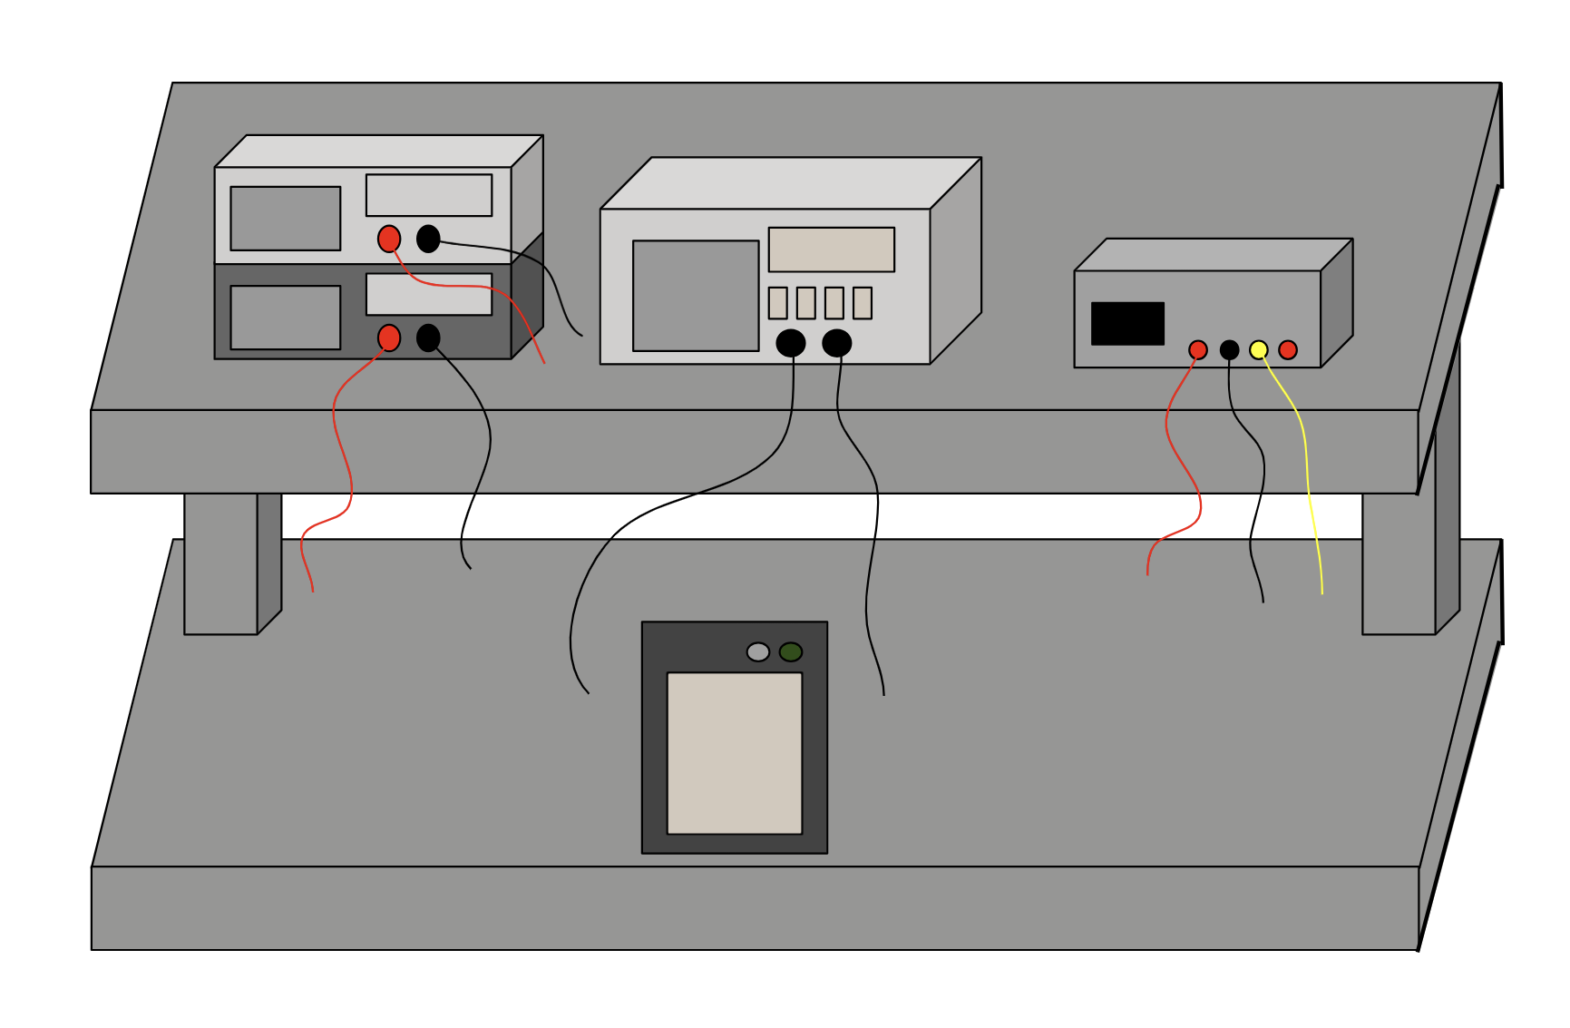

Figure (1): Workspace setup showing the digital multimeter and signal generator (left), the oscilloscope (middle), the power supply (right) and the breadboard (bottom).

For this experiment, the breadboard was used to connect the components used to build the filters, the digital multimeter was used to measure resistances and capacitances of components more accurately, the oscilloscope was used to measure the input and ouput voltages, the power supply was used to supply the voltage to the “+” and “-“ pins of the OP07, the signal generator was used to provide in input voltage, and the OP07 was used as the operational amplifier for each of the filter constructed.

For the first section of this laboratory each of the circuits to be tested (Figures 2-5) were simulated using LTSpice.

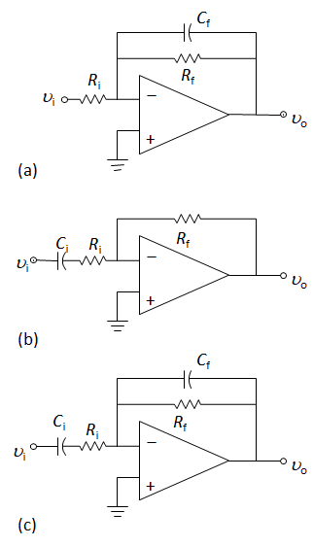

Figure (2): Inverting Low Pass Active Filter

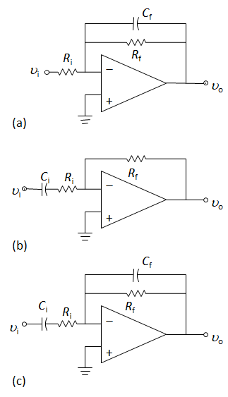

Figure (3): Inverting High Pass Active Filter

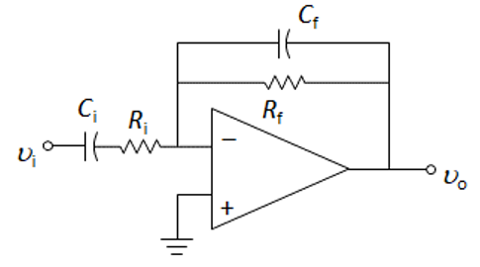

Figure (4): Inverting Bandpass Filter

+

−

*V*in

*V*o

Figure (5): Sallen-Key Second Order Low Pass Filter

For the low pass filter in figure (2), a feedback capacitor of 4.7 nF was selected with a corner frequency of 300Hz and a gain of 20dB. The feedback resistor was calculated using the corner frequency equation shown in equation (1) and the input resistor was calculated using the gain equation of an inverting operational amplifier shown in equation (2). The gain in V/V was found from the gain in dB using equation (3).

|  |  |  |
| --- | --- | --- |
|  |  | Equation (1) |
|  |  | Equation (2) |
|  |  | Equation (3) |

A similar procedure was performed for the high pass filter in figure (3). The corner frequency was selected as 5Hz and the input capacitor was selected to be 1 µF with the gain also being 20dB. The corner frequency equation for a high pass filter (equation (4)) was used to find the size of the input resistor and the gain equation was used to find the value of the feedback resistor. (Insert transfer function for high pass filter)

|  |  |  |
| --- | --- | --- |
|  |  | Equation (4) |

For the band pass circuit in figure (4), The corner frequencies from the two previous circuit were used along with a gain of 20dB. 1 µF was used for the value of the input capacitor and the previous equations were used to get the values of the rest of the components. The transfer function for this filter is shown in equation (5). Equation (6) and (7) are equations relating to the time constant of the input and output of the circuit respectively.

|  |  |  |
| --- | --- | --- |
|  |  | Equation (4) |
|  |  | Equation (5) |
|  |  | Equation (6) |

Finally, for the Sallen-Key filter in figure (5), the values of the componants were chosen as follows: , , , . Being that this is a second order filter, the transfer function is a bit more complicated. The transfer function can be seen in equation (7) and in terms of omega in equation (8).

|  |  |  |
| --- | --- | --- |
|  |  | Equation (7) |
|  |  |  |
|  |  |  |
|  |  | Equation (8) |

Along with this, the peak frequency value and the magnitude at this peak can be seen in equations (9) and (10) respectively.

|  |  |
| --- | --- |
|  | Equation (9) |

|  |  |
| --- | --- |
|  | Equation (10) |

Lastly, equation (11) was used to determine the overshoot of the system in response to a step function input.

|  |  |
| --- | --- |
|  | Equation (11) |

Figure (6) shows an example of the circuit construction for the low pass and high pass filter.

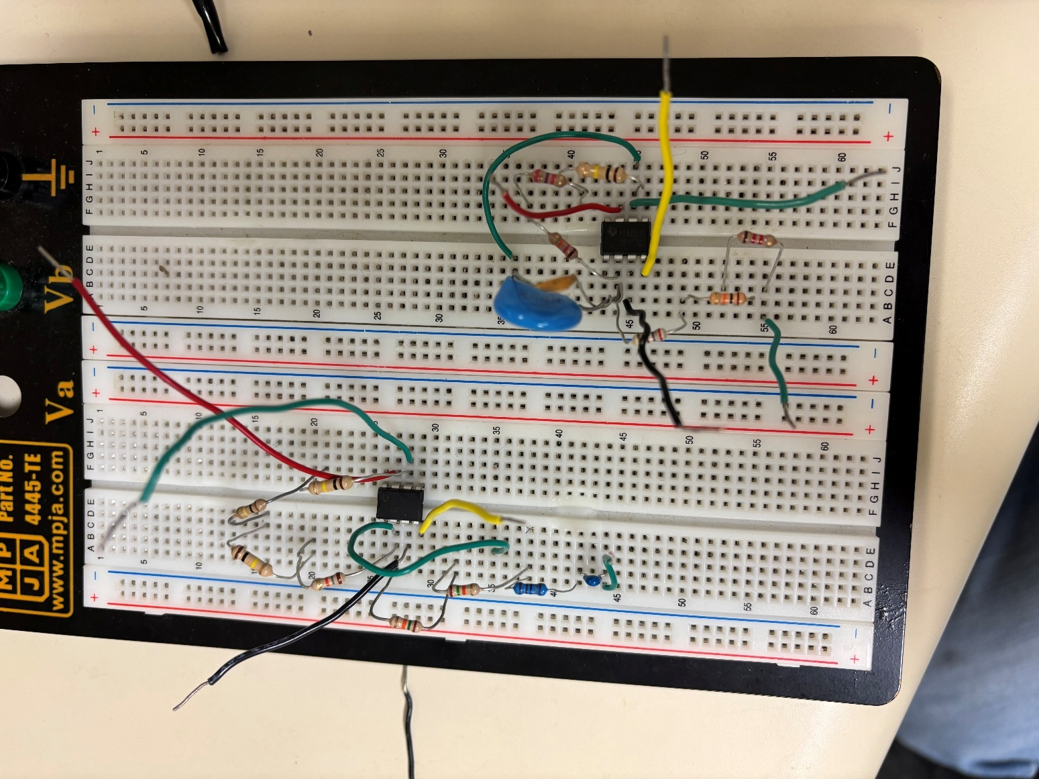

Figure (6): Circuit Construction of Low Pass Filter (Left) and High Pass Filter (Right)

**Filter Testing procedure**

For each of the first three filters, each of the components selected was measured using the digital multimeter for more accurate theoretical data analysis. After these components were measured, each circuit was constructed and tested at various frequencies. The frequencies selected for this experiment were 1, 3, 10, 30, 100, 300, 1000, and 10000 Hz. To find the gain at each frequency, the output voltage amplitude was divided by the input voltage amplitude. To find the phase change, the number of divisions between the zero crossing of each waveform was found. This was used to find the phase change in degrees at a particular sec/division setting. The equation used for this process can be seen in equation (12).

|  |  |  |
| --- | --- | --- |
|  |  | Equation (12) |

Finally, for the Sallen-Key filter, a similar bode plot was constructed. The theoretical values of the frequency of the peak gain as well as the peak frequency were also solved for and compared with the experimental data. Along with this, a square wave input was used to test the step response of the circuit in order to measure the percent overshoot.

**Results**

Pre-Lab LTSpice Simulations

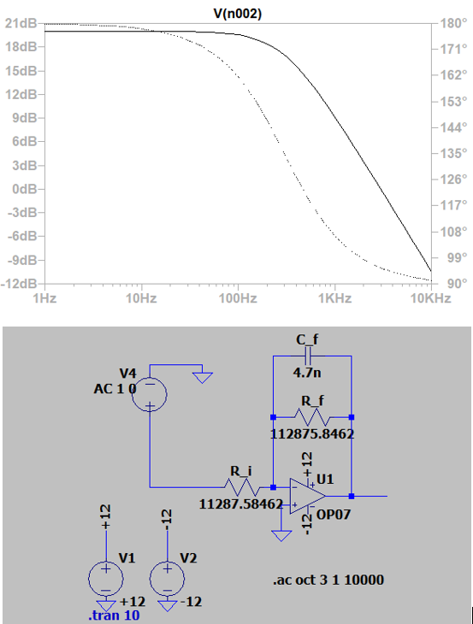

Figure (): LTSpice Simulation of Low Pass Filter.

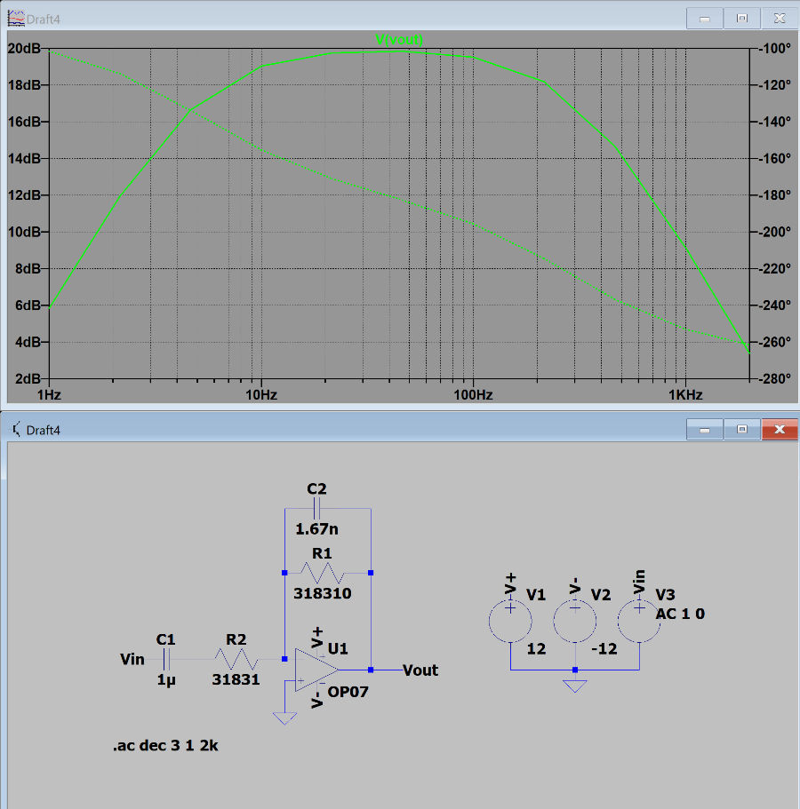

Figure (): LTSpice Simulation of Band Pass Filter

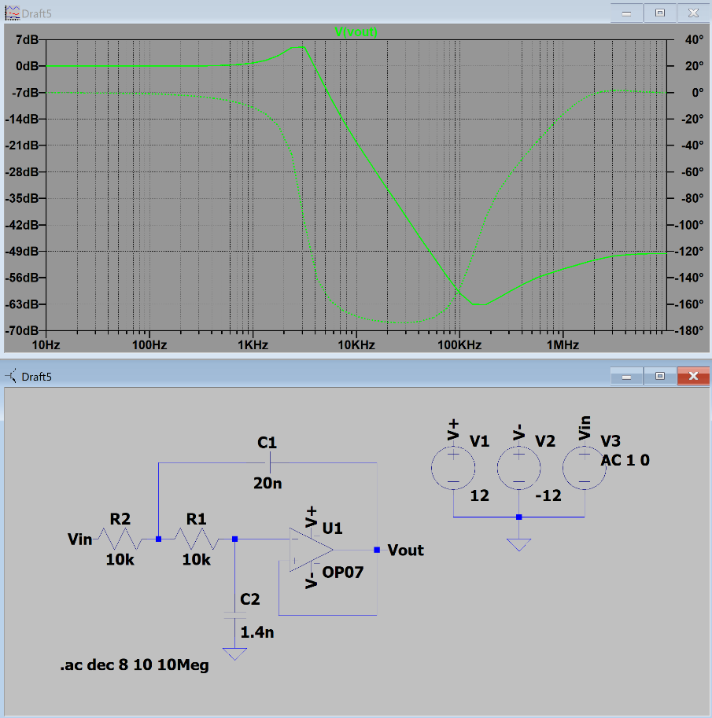

Figure (): LTSpice Simulation of Sallen-Key Filter

Low Pass Filter

The magnitude of the transfer function of this filter can be found by taking the magnitude of equation (3). This is shown in equation (). The phase of this transfer function is shown in equation (). Table () shows the values associated with the components of this filter along with the time constants. Figure () and () show the magnitude and phase plots of the filter.

|  |  |  |
| --- | --- | --- |
|  |  | Equation () |
|  |  | Equation () |

Table (): Circuit Components and Time Constants of Low Pass Filter

|  |  |  |  |  |  |  |  |  |  |
| --- | --- | --- | --- | --- | --- | --- | --- | --- | --- |
|  | **Calculated Values** | | **Unit** | | **Measured Values** | **Unit** |  | **Tf** | 0.00053 |
| **Rf** | 112.875 | | Kohm | | 112.85 | Kohm |  |  |  |
| **Ri** | 11.287 | | Kohm | | 11.3 | Kohm |  |  |  |
| **Cf** | 4.7 | | nF | | 4.7 | nF |  |  |  |
|  |  |  | |

Figure (): Magnitude Bode Plot for Low Pass Filter

Figure (): Phase Bode Plot for Low Pass Filter

Band Pass Filter

The magnitude of the transfer function of this filter can be found by taking the magnitude of equation (4). This is shown in equation (13). The phase of this transfer function is shown in equation (14). Table () shows the values associated with the components of this filter along with the time constants. Figure () and () show the magnitude and phase plots of the filter.

|  |  |  |
| --- | --- | --- |
|  |  | Equation (13) |
|  |  | Equation (14) |

Table (): Circuit Components and Time Constants of Band Pass Filter

|  |  |  |  |  |  |  |  |
| --- | --- | --- | --- | --- | --- | --- | --- |
|  | **Calculated Values** | **Unit** | **Measured Values** | **Unit** |  | **Ti** | 0.033685 |
| **Rf** | 318.31 | Kohm | 315.18 | Kohm |  | **Tf** | 0.000523 |
| **Ri** | 31.831 | Kohm | 31.57 | Kohm |  |  |  |
| **Cf** | 1.67 | nF | 1.66 | nF |  |  |  |
| **Ci** | 1 | uF | 1.067 | uF |  |  |  |

Figure (): Magnitude Bode Plot for Band Pass Filter

Figure (): Phase Bode Plot for Band Pass Filter

Sallen-Key Filter

The magnitude of the transfer function of this filter can be found by taking the magnitude of equation (8). This is shown in equation (15). The phase of this transfer function is shown in equation (16). Table () shows the values associated with the components of this filter along with the time constants. Figure () and () show the magnitude and phase plots of the filter.

|  |  |  |
| --- | --- | --- |
|  |  | Equation (15) |
|  |  | Equation (16) |

Table (): Circuit Components and Values Associated with Sallen-Key Filter

|  |  |  |  |  |  |  |  |
| --- | --- | --- | --- | --- | --- | --- | --- |
|  | **Theoretical Values** | **Unit** | **Measured Values** | **Unit** |  | **w0** | 18572.24 |
| **R1** | 10 | Kohm | 9.92 | Kohm |  | **zeta** | 0.268579 |
| **R2** | 10 | Kohm | 9.89 | Kohm |  |  |  |
| **C1** | 1.4 | nF | 1.46 | nF |  |  |  |
| **C2** | 20 | nF | 20.24 | nF |  |  |  |

Figure (): Magnitude Bode Plot for Sallen-Key Filter

Figure (): Phase Bode Plot for Sallen-Key Filter

Table () and () show the theoretical frequency and magnitude values associated with the sallen key filter and figure () shows the oscilloscope waveform associated with the step response of the filter.

Table (): Theoretical Peak Frequency and Magnitude of Sallen-Key Filter

|  |  |  |  |
| --- | --- | --- | --- |
|  |  | **Radians** | **Degrees** |
| **Peak Frequency** | | 17180.39 | 2734.344 |
|  |  |  |  |
|  |  | **V/V** | **dB** |
| **Peak Magnitude** | | 1.932662 | 5.723117 |

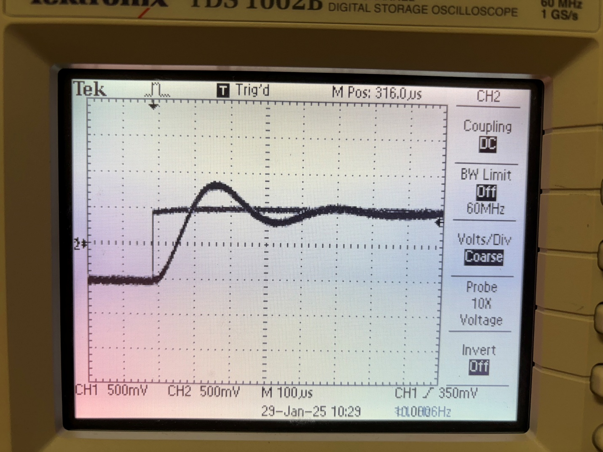

Figure (): Oscilloscope Waveform Showing Step Response of Sallen-Key Filter

Table (): Comparison of Theoretical and Experimental Percent Overshoot.

|  |  |  |  |  |
| --- | --- | --- | --- | --- |
|  |  | **Value (V)** | **Percent** | **Theoretical Percent** |
| **Overshoot** | | 0.35 | 35 | 41.64664187 |

**Discussion**

Low Pass Filter

From the data from LTSpice, theory and experiment, we can see that the magnitude are all very similar and support the hypothesis that the currently accepted theory surrounding the low pass filter is still reliable. With this being said, there is still some inherent error in the data that could be attributed to background noise or other small inconsistencies.

High Pass Filter

Band Pass Filter

Looking at the data for the band pass filter, we can see that the data from LTSpice, the experimental data, and the theoretical data all are very similar and support the hypothesis that the currently accepted theory surrounding the band pass filter is still reliable. With this being said, there is still some inherent error in the data that could be attributed to background noise or other small inconsistencies.

Sallen-Key Filter

Looking at the data for the Sallen-Key filter, we can see that the data from LTSpice, the experimental data, and the theoretical data all are very similar and also support the hypothesis that the currently accepted theory surrounding the band pass filter is still reliable. As stated before, there is still some error associated with various near-negligible inconsistencies.

The theoretical value of the peak frequency of the filter was found to be about 2.7kHz using equation (9). This value is very similar to that of the LTSpice plot and the plot generated using the experimental data. With this being said, more measurements could have been taken to provide a more accurate measure of the peak. The magnitude of the peak found using equation (10) was nearly a gain of 2 V/V (6dB). This is also supported by the experimental data. As before, more data points could have been taken to get a more accurate idea of the peak value.

Finally, we see that the theoretical and experimental percent overshoot are similar, but not as similar as some of the other data in the experiment with a percent error of about 16%. This is a relatively large percent error, and this error is likely due to level of specificity of the oscilloscope. A smaller voltage/divisions might have helped to get a more accurate value.

**Conclusion**

The primary focus of this lab was designing, constructing, and testing active filters using operational amplifiers, following specifications commonly found in bioinstrumentation devices. The goal was to compare the theoretical frequency response of each filter with experimental data, emphasizing their similarities and error. Additionally, the Sallen-Key filter, a second-order filter, will be examined to determine whether its peak frequency, peak magnitude, and step response align with established theoretical expectations. With these objectives in mind, we believe we have shown that the established theories, equations, and construction methods for these filters remain valid based on the data presented in this lab.

1.